Homework # 3

Ruchi Panwar (rpanwar@kent.edu)

Advance Database

Fall 2015

Professor: Dr. Gregory S DeLozier

Sept 22, 2015

**Bottlepy Tutorial & First Todo App (Using Python & PythonAnywhere)**

Bottlepy Tutorial : http://bottlepy.org/docs/dev/tutorial.html

**First Program : app.py**

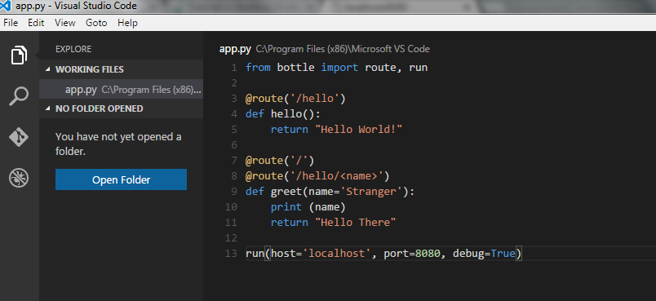

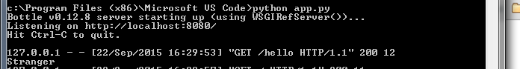

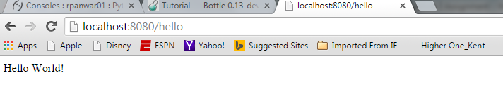

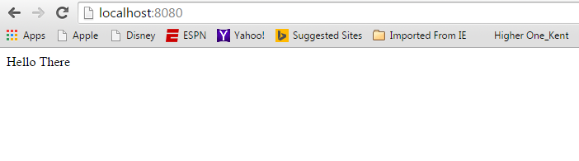



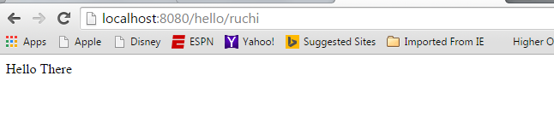



**Template Program:**

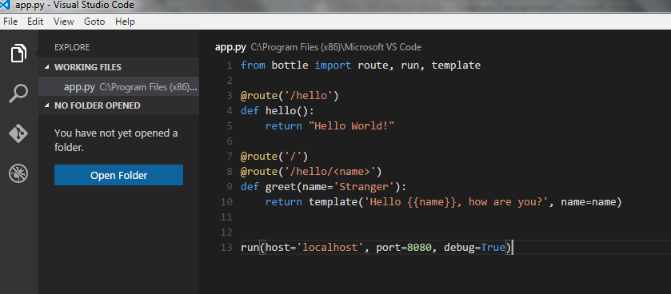

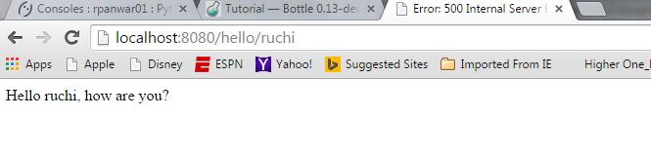

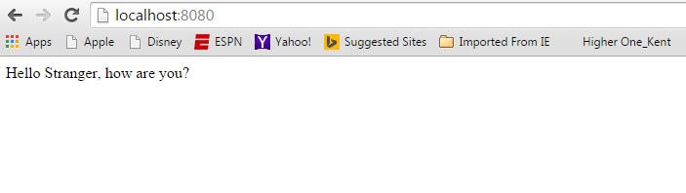

**Login application:**

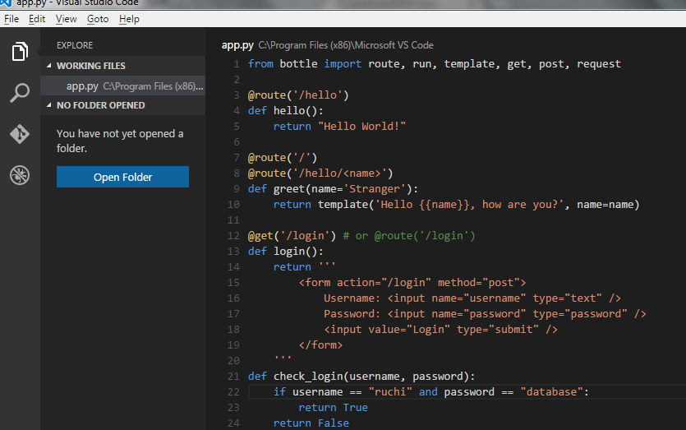

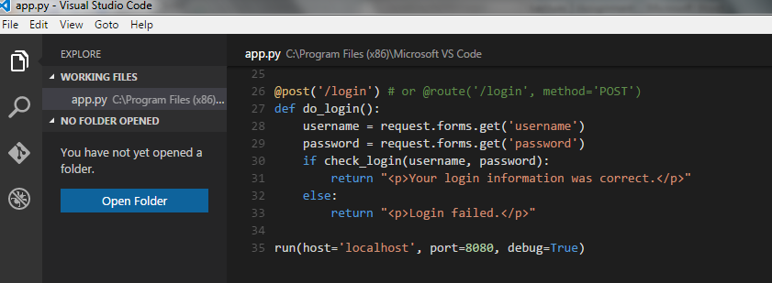

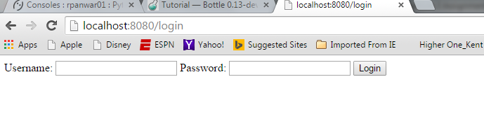

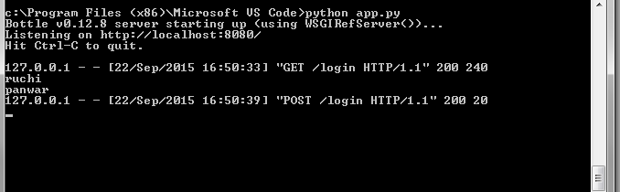

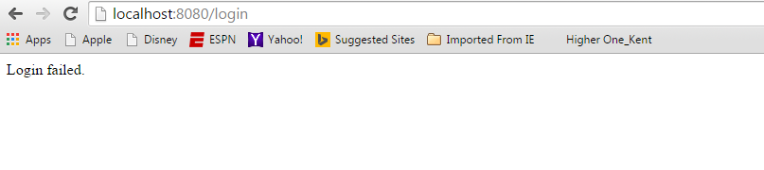

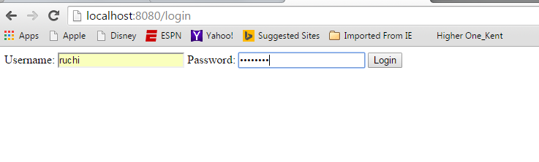

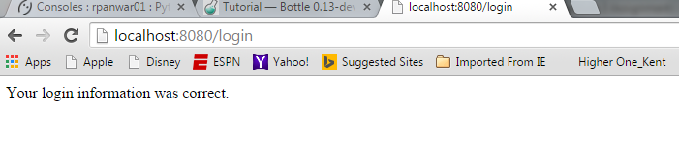

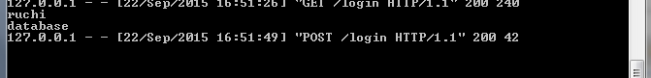

**First Program using .tpl file :**

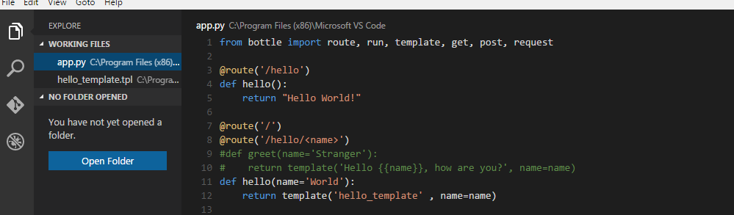

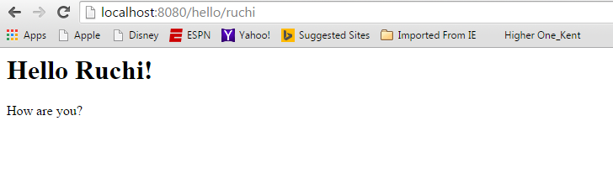

**Bottlepy SQLite tutorial on PythonAnywhere:**

Bottlepy SQLite tutorial Page: http://bottlepy.org/docs/dev/tutorial_app.html

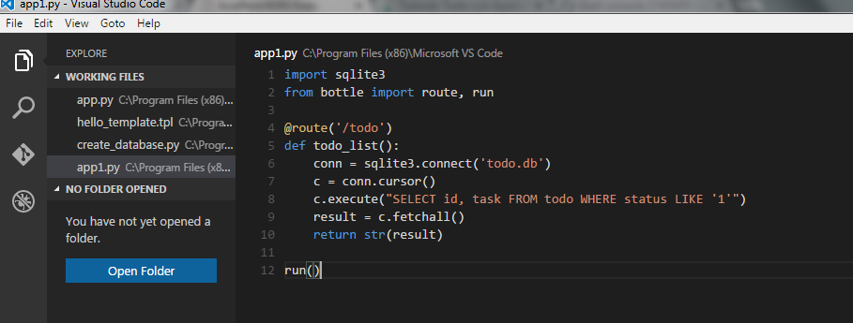

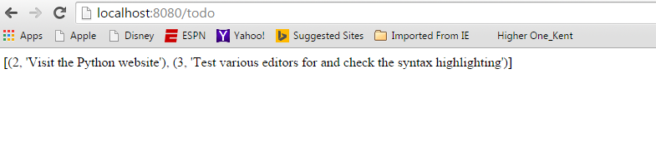

**First Todo App using Visual Studio Code:**

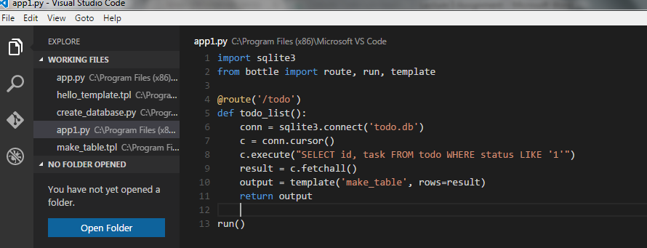

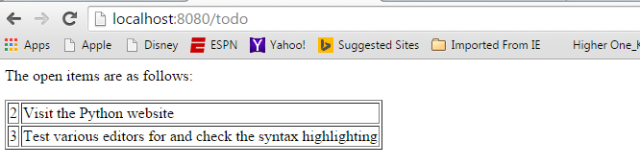

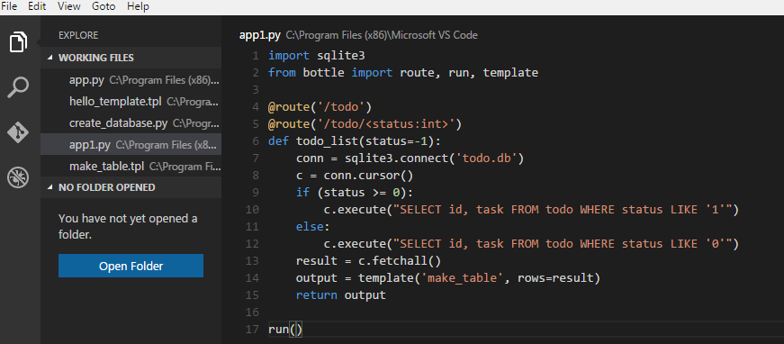

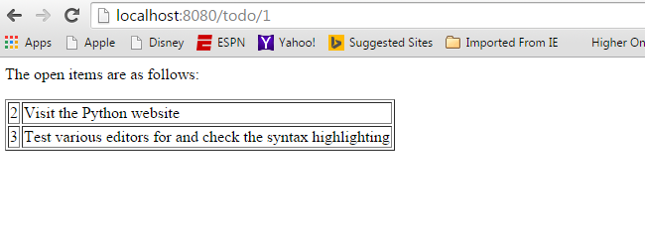

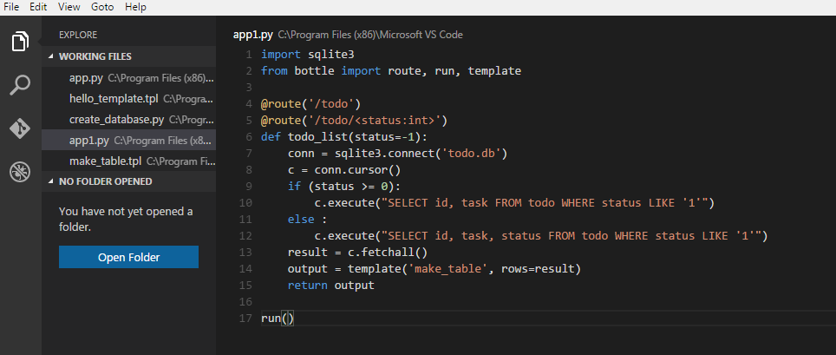

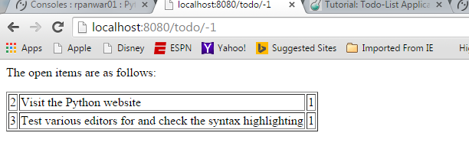

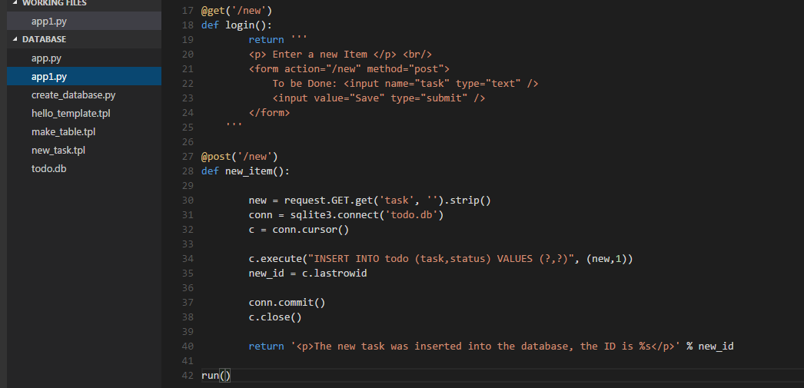

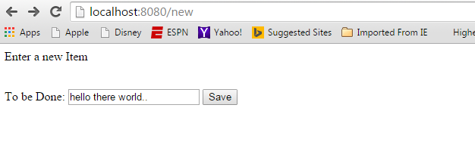

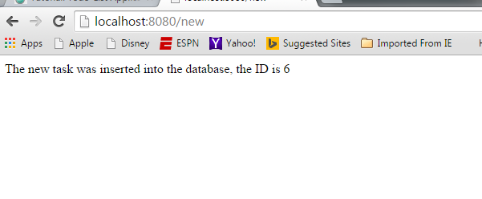

**First Todo app on PythonAnywhere:**

